

Assignment 2

IMAD5112



May 6, 2024

ST10440871

Atiyha Haripersadh

***Contents***

**What is a Tamagotchi?** 2

**How I interpreted making my Tamagotchi application.** 3

**How the application should work.** 4

**Finding my character.** 5

**How I came to designing my application.** 7

**My coding.** 10

**What I learnt from making this Tamagotchi application.** 11

**YouTube video link.** 11

**Referencing/Bibliography.** 12

# **What is a Tamagotchi?**

Is a handheld digital pet that was created in Japan by Akihiro Yokoi of Wiz and Aki Maita of Bandai. It was first released in Japan on 23 November 1996 and in the United States on 1 May 1997. It was a very popular toy to have during the late 1990s and early 2000s.

When playing with it, an egg would appear on screen for it to hatch, after setting the clock on it, the egg will wiggle and further hatch. A few updates after the first Tamagotchi, the user was able to enter their age and name, as well as name their pet, learn of its family group and/or gender. Pets generally had a hunger meter, happy meter and training meter to determine how healthy their pet is. Filling up the hunger meter can be achieved by feeding the pet a meal or snack. Filling up the happy meter was achieved by playing mini-games with their pet or by feeding them a snack. Training meter previously known as the discipline meter was filled by pressing scold when the pet calls for attention despite it neither being hungry or happy. Later models had “praise” for when your pet was sulking or performs good deeds. If the pet needed the bathroom it would make a face and “stink” lines would appear around it, if the user pressed the toilet icon, it would allow for the pet to use the bathroom, the more frequent this happens allows for your pet to be potty trained.

If your pet gets sick a skull icon would appear next to your pet as sits at the bottom of the screen, being unhappy. The pet can die if sickness is left unchecked, it could be cured by pressing “medicine” however it would need to be pressed more than once. The illnesses it could have are being over fed, failing to allow the usage of the bathroom.

# **How I interpreted making my Tamagotchi application.**

While I could not animate my own character for the application, I decided to look into apps that were similar to a Tamagotchi. I found two that I used to play growing up, My Talking Tom, Moy, and POU (iTechnoLabs). I also found some other applications like, My Tamagotchi Forever, Bubbu, My Boo, Dogotchi, and Hellopet (wondershare, 2024).

I then planned it out, I came to the conclusion that I would not be able to animate a character so I would have to edit the pictures to change with each button click, as well as I’d have to find or create a character and have multiple images of the character doing different things, like eating, playing and bathing or cleaning itself.

I came to the realization that the original Tamagotchi was pixelated, so I thought back to a game I used to play that was revolved around pixels and blocks, Minecraft.

# **How the application should work.**

First the application should open onto an introduction page, where you would be greeted with an egg that contains your Tamagotchi pet. It would have the title of the application as well as a progression button labelled as, “start”.

After pressing the “start” button you should redirected to the main page where you are greeted with your Tamagotchi pet. It should have a brief introduction of the name of your pet.

Below the image of your pet, you should see three buttons, one to feed your pet, one to clean your pet, and one to make your pet happy. Below the buttons there should also be a progression bar as an edit text.

When you click on each of the buttons, the image of your pet should change as well as the progression bar.

# **Finding my character.**

I then searched for an animal I could use as a character, but I did not want it to be a popular domesticated animal from the game.

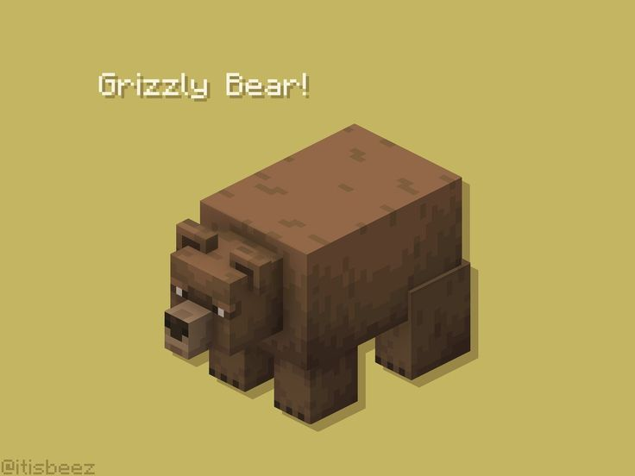(<https://i.pinimg.com/originals/71/a8/60/71a860d3e54ec766f1768e14c8810200.jpg>)

I chose to do a Grizzly Bear because it is an animal people would not generally domesticate because of how dangerous they can be, as well as because they’re the general animal that is made cute, for example, a teddy bear.

I then looked for more images for Eating.

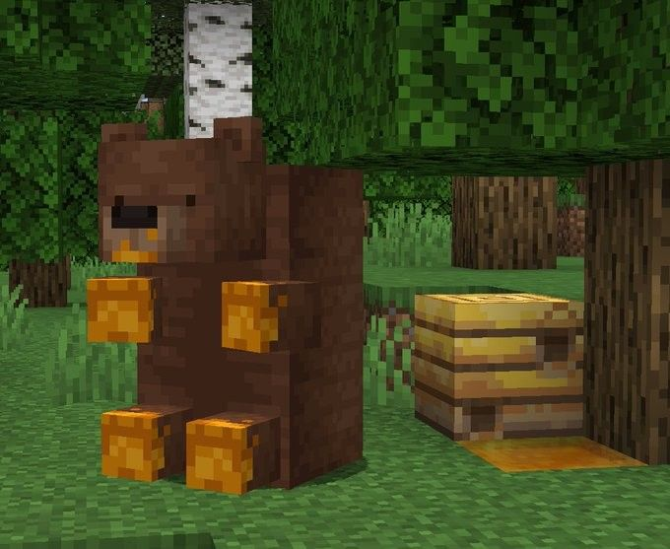(<https://i.pinimg.com/originals/a7/0a/71/a70a71692ae6f192bd1f2feb45f37c27.jpg>)

I looked for a picture for cleaning.

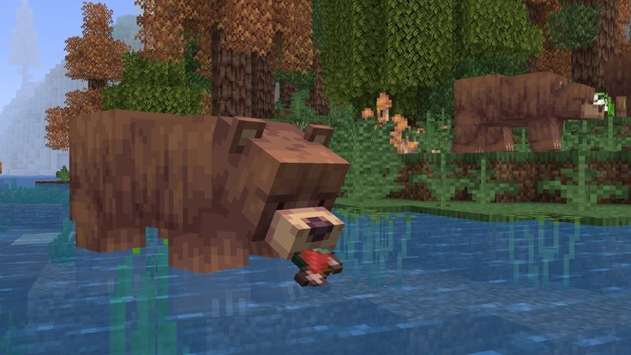(<https://i.pinimg.com/originals/4a/af/64/4aaf6424f4b6052597d64a1d414f5f34.jpg>)

I looked for a picture for a bear being happy.

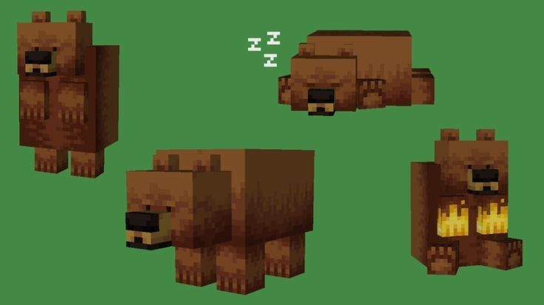(<https://i.pinimg.com/originals/d4/d3/1b/d4d31b1d9a765f44bab6aa8f9ba01591.jpg>)

While there are multiple images of bears in this picture, I chose the one of the bear standing.

# **How I came to designing my application.**

For the first page of my application, I came to the conclusion that I wanted the background to still stick to the block, pixel, theme, as the original Tamagotchi was pixel. As well as I wanted it to be something vibrant yet not too distracting.

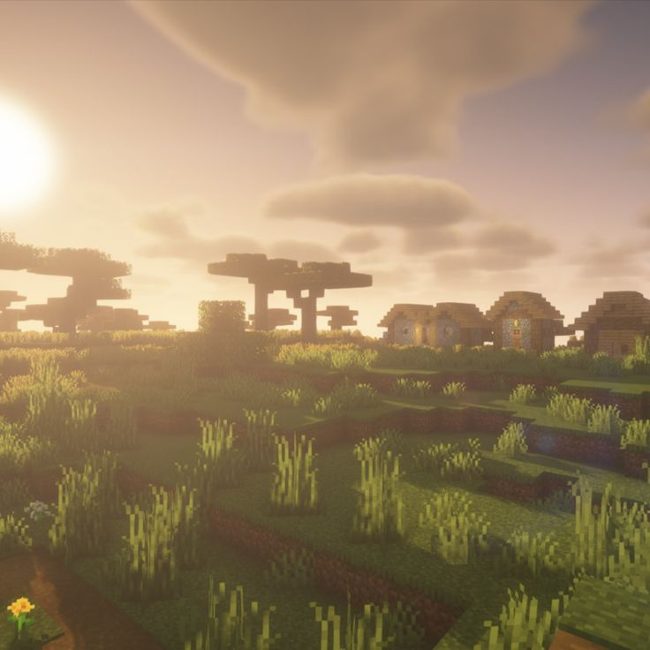(<https://i.pinimg.com/originals/aa/b6/59/aab659b0bfe83a7cedb221f91323a288.jpg>)

I decided on a sunrise as it is a representation of something new, fresh and beautiful.

I also decided to add an egg as tribute to the original Tamagotchi as in the original, the animal would hatch from the egg.

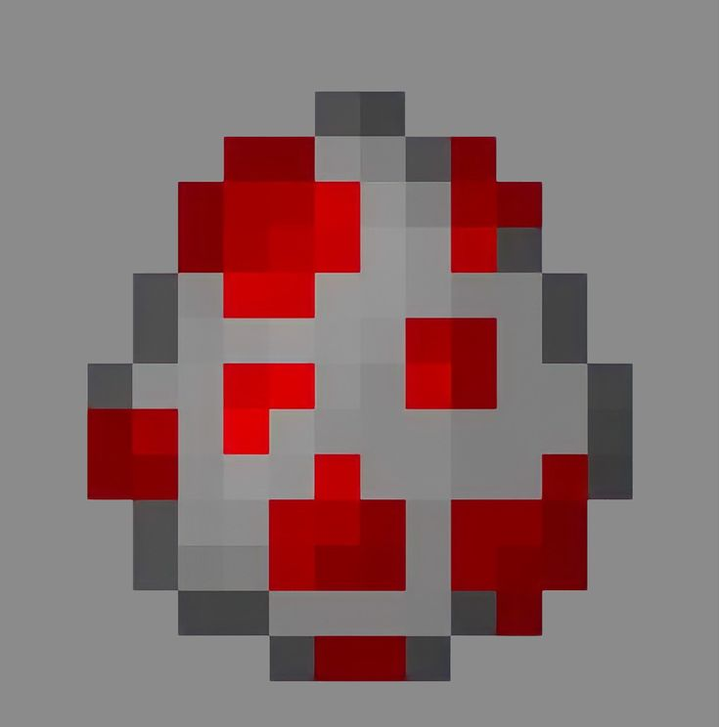(<https://i.pinimg.com/originals/1c/93/bc/1c93bc25c868006023c1ba08d4ae3550.jpg>)

I then added a button to move to the main page.

This is what my introduction page for my application looked like.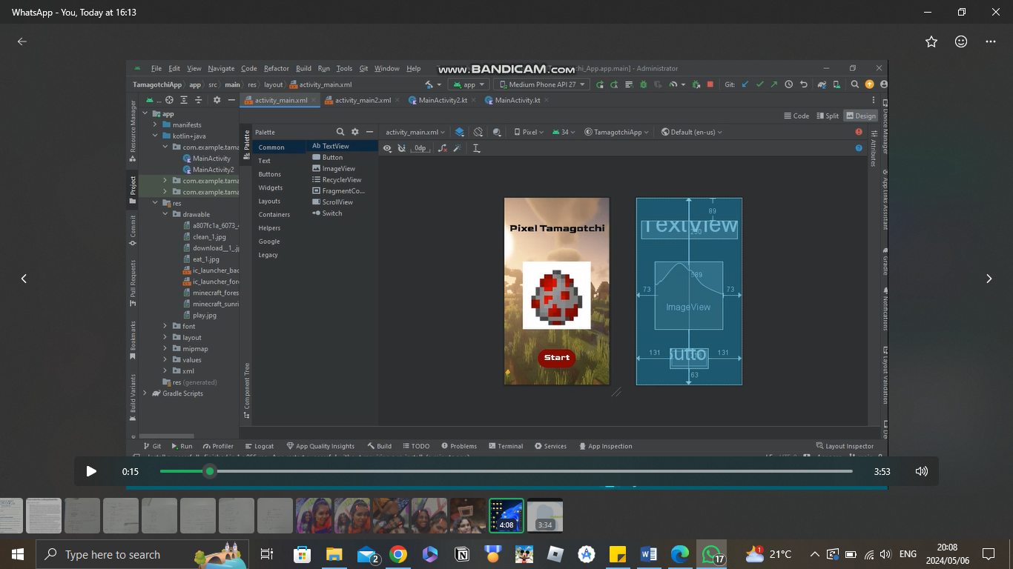

On the main page I chose the background to be the natural habitat of a bear.

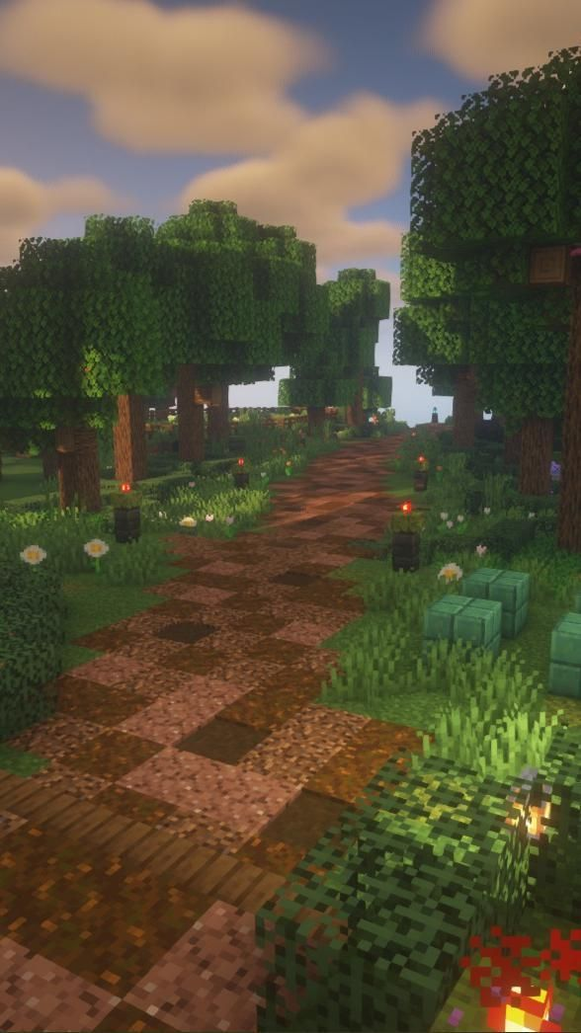(<https://i.pinimg.com/originals/33/98/dc/3398dcae9c77c248873b2baf5630de97.jpg>)

This is what my main page looks like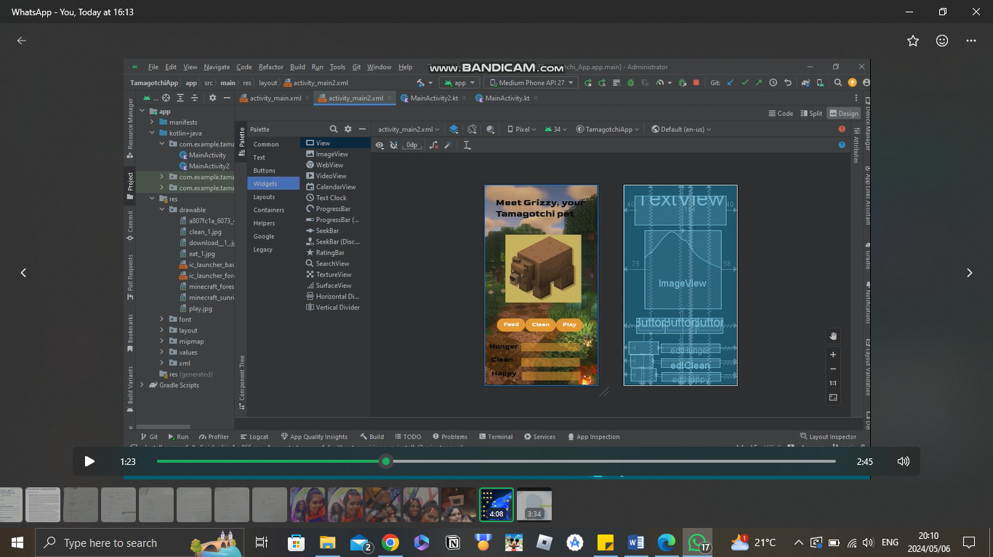.

# **My coding.**

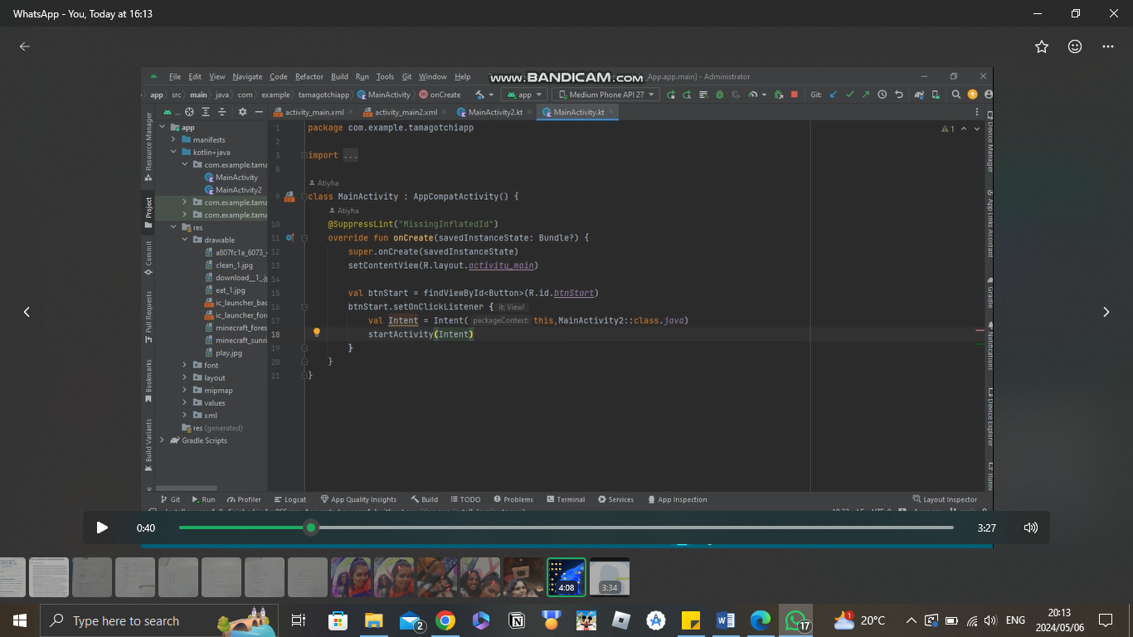

For the first page of coding I initialised the button and linked the main page to the button so when the start button is clicked it takes the user to the main page.

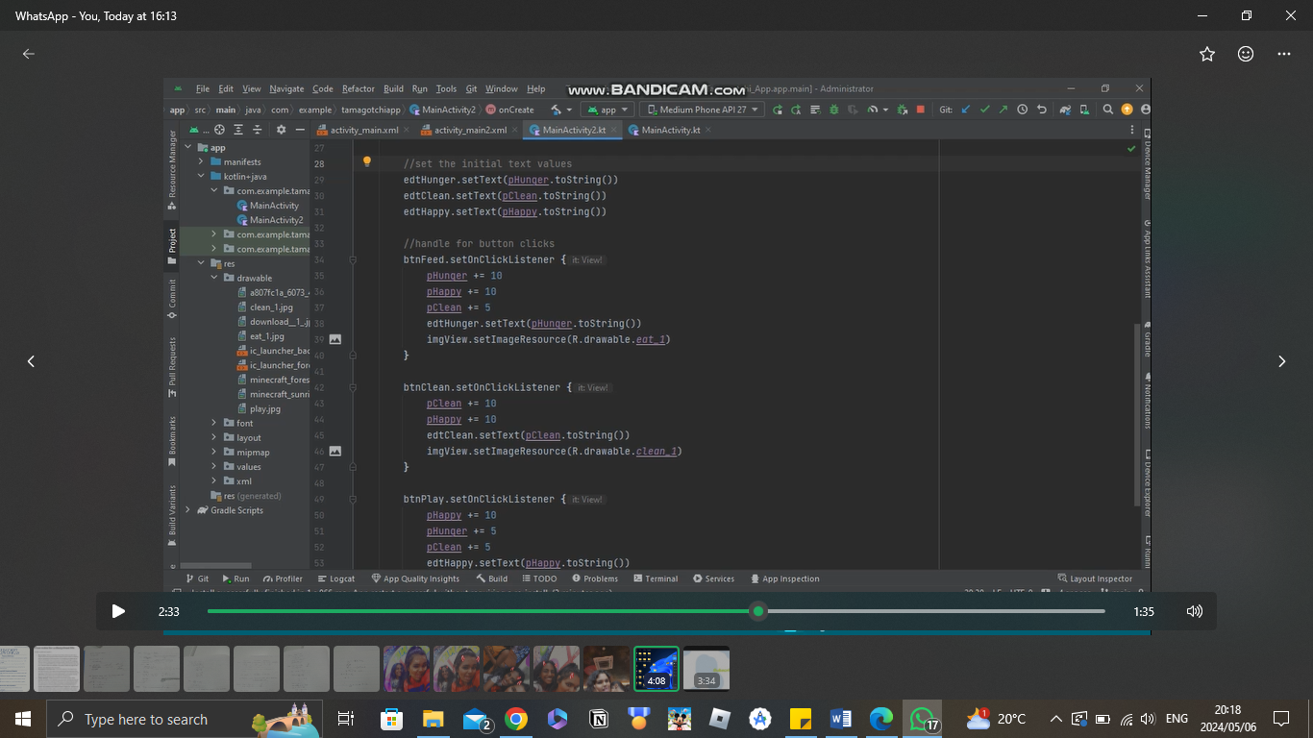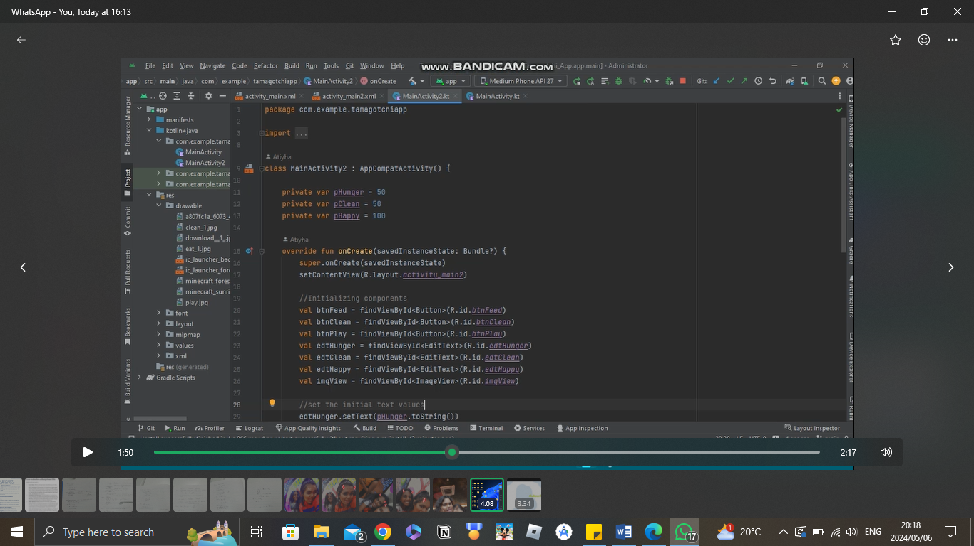

In the coding of the second/main page I first declared the variables privately and initialized them to a certain number, these are for the progress bar.

I then initialized and declared each component that I used, and set each Edit Text as a string. Within the three buttons I first initialised and added to the progression bar, each being a different amount added depending on what button was pressed. As well as for each button clicked the image is to change to show the bear doing something different.

# **What I learnt from making this Tamagotchi application.**

While making this application, I came to the understanding of how easy the concept of making an application or game like this is. Yes it would better if we could animate it to make the visuals for the user interface look more seamless. Although besides that, the general concept of creating a character where you have to feed, play and clean your pet would be easy.

Besides that, I also learnt from the mistakes I made while pushing my code into GitHub, as compared to my previous assignment. My mistake in my previous assignment is that I while making my repository for my code, I didn’t add a license as well as that I did not change the Gitgnore to Kotlin, making it difficult to run my code.

I also learnt how to link pages and to make them visible with a push of a button. As well as changing images from the original set image to a different image, all with the push of a button.

# **YouTube video link.**

<https://youtu.be/0DHx7q4Gzz4>

# **GitHub repository.**

# **Referencing/Bibliography.**

* [Online] URL Available at:

<https://i.pinimg.com/originals/a7/0a/71/a70a71692ae6f192bd1f2feb45f37c27.jpg> or <https://za.pinterest.com/pin/777856166920045844/> [6 May 2024]

* [Online] URL Available at:

<https://i.pinimg.com/originals/71/a8/60/71a860d3e54ec766f1768e14c8810200.jpg> or <https://za.pinterest.com/pin/777856166920046145/> [6 May 2024]

* [Online] URL Available at:

<https://i.pinimg.com/originals/1c/93/bc/1c93bc25c868006023c1ba08d4ae3550.jpg> or <https://za.pinterest.com/pin/54817320457769030/> [6 May 2024]

* [Online] URL Available at:

<https://i.pinimg.com/originals/4a/af/64/4aaf6424f4b6052597d64a1d414f5f34.jpg> or <https://za.pinterest.com/pin/777856166920045757/> [6 May 2024]

* [Online] URL Available at:

<https://i.pinimg.com/originals/d4/d3/1b/d4d31b1d9a765f44bab6aa8f9ba01591.jpg> or <https://za.pinterest.com/pin/777856166920045747/> [6 May 2024]

* [Online] URL Available at:

<https://i.pinimg.com/originals/aa/b6/59/aab659b0bfe83a7cedb221f91323a288.jpg> or <https://za.pinterest.com/pin/777856166920092545/> [6 May 2024]

* [Online] URL Available at:

<https://i.pinimg.com/originals/33/98/dc/3398dcae9c77c248873b2baf5630de97.jpg> or <https://za.pinterest.com/pin/25473554135904397/> [6 May 2024]

* iTechnoLabs. (2024) Top 12 Virtual Pet Games in 2024, Including Sylestia Platform [Updated], 30 April 2024. [Online] URL Available at:

<https://itechnolabs.ca/top-virtual-pet-games/> [6 May 2024]

* Wikipedia. (2024) Tamagotchi, 28 April 2024. [Online] URL Available at:

<https://en.wikipedia.org/wiki/Tamagotchi> [6 May 2024]

* Wondershare. (2024) Discovering a Virtual Pet With Top 10 Option For Endless Fun, 20 March 2024. [Online] URL Available at:

<https://repairit.wondershare.com/ai-tools/virtual-pet-adoption-games.html?source=8&third_register=1> [6 May 2024]